SmartReport AI - Leveraging Multi-Agent Intelligence for Deep Report Analysis, Insight Discovery, and Personalized Recommendations

Shobana G
Department of Artificial Intelligence and data science
Sri Eshwar College of Engineering
Coimbatore,India shobana.g@sece.ac.in
Pragateesh G
Department of Artificial Intelligence and data science
Sri Eshwar College of Engineering
Coimbatore,India
pragateesh.g2022ai-ds@sece.ac.in
Vetrivel A
Department of Artificial Intelligence and data science
Sri Eshwar College of Engineering
Coimbatore,India
Vetrivel.a2022ai-ds@sece.ac.in
Rudresh J D
Department of Artificial Intelligence and data science line Sri Eshwar College of Engineering
Coimbatore,India
rudresh.jd2022ai-ds@sece.ac.in

Abstract: SmartReport AI is the highly sophisticated array of AIs capable of analyzing documents of unlimited domains in real time. It extracts data on various sources and points out significant points and provides concrete solutions. It decodes the info, identifies what is important, and offers domain advice in the form of a group of autonomous agents: a Domain Identifier, Insight Generator, Suggestion Engine, a Goal-Directed Agent, and a RAG-based Conversational Agent. The system uses transformer-based NLP to create semantic embeddings using Sentence Transformers and performs a quick search of vectors by using FAISS. It is capable of addressing any issue, killing the most important information, and making guesses as to what the user desires at that particular moment. As time goes by, it continuously sharpens itself, thus becoming easy to add new data and adjust to the needs of the user. It responds faster and with a higher accuracy than existing RAG systems by 17 similar topics with an average reply time of 1.3 seconds and 91.2 percent accuracy. Concisely, SmartReport AI provides a dynamic and strong real-time information synthesis of various data types, which has become a new standard of automated knowledge management, interactive query response, and complete multi-domain document understanding due to a clever combination of smart search, generative reasoning, and multi-agent collaboration.
Keywords— SmartReport 1 AI, Multidomain Document Analysis, Information Extraction, Natural Language Processing (NLP), Retrieval Augmented Generation (RAG), Multi-agent Collaboration, Insight Generation, Real-Time Data Analysis, Knowledge Management.

Introduction
We are always awash with masses of unstructured information- docs, reports, web pages. It is like chasing a moving object to sift through this stuff. Conventional methods falter due to the diverse formats, complicated sentence constructions and subtext. SmartReport AI is an attempt to address this by combining multi-agent AI models, RAG, and the latest NLP to sift, index, and synthesize unstructured text systematically. It gets a huge score in that it transforms an unorganised analysis pipeline into a time-saving process that improves the quality of a decision, as well. Transformer models combined with knowledge-retrieval tools allow it to detect concealed data points that regular tools are unaware of. As a bonus, we also added some under-sampling and over-sampling to ensure the distinction between bad and good content is further differentiated- good with the security gaps such as phishing URLs. Another study that we conducted was the use of AI in multi-agent data-extraction and security, demonstrated with Phish Guard, which provides an authentic, real-time phishing detection based on a similar basis. This all demonstrates the fact that smart document analysis can be very powerful and flexible throughout the board.

Literature Review
Recent advances in large language models are eliminating performance bottlenecks and together with more recent retrieval models, as well as agent-based systems, we are witnessing actual progress in multi-domain document analysis. The emphasis is currently on multi-agent systems that work together and employ RAG pipelines to crunch, reason, and integrate the information of numerous disciplines. That is precisely what SmartReport AI offers, a few agents on a collaborative RAG structure to scale the analysis of documents of different types. This allows the system to pick up on the finer semantic and context-driven associations that an individual agent or the traditional retrieval model would overlook. SmartReport AI is capable of pulling and adapting information in real time and therefore can dynamically rearrange its own workflow based on the query of the user. This implies that it will be able to tailor responses and keep in line with evolving needs. We believe that embeddings with Sentence Transformers and the use of FAISS with vectors to perform a lookup is fast, accurate, and reliable and provides our users with confidence. One of the studies by Li et al. demonstrated that multi-agent orchestration could enhance cross-domain extraction to allow collaborative, domain-specific reasoning. Based on this, we developed SmartReport AI that integrates domain classification, insight generation, recommended actions, and goal-focused reasoning into a single, streamlined, autonomous workflow.

Together with the embedding-based retrieval research, it is also excitable to get contextual information within documents. Luo et al. suggested a context-sensitive retrieval model with semantic embeddings to overcome semantic drift and enhance document comprehension. Their implementation, however, lacked a generative component so that it could not self-adapt. To resolve that, we proceeded to pair FAISS retrieval with transformer-driven generators and allowed SmartReport AI to generate real-time summaries, inferences, and insights that align with the user queries. The addition of RAG pipelines to multi-agent systems has made the extraction of knowledge faster. According to Sharma and Gupta, when they combined agent-based systems with RAG, the response was more context-relevant, but they applied pre-constructed, stiff workflows that restricted flexibility. SmartReport SmartReport AI has considered that by allowing the dynamically orchestrated agents, even a back-and-forth chat chat can be addressed with a RAG-powered chatbot. That enhances context insight and makes the reports come up to what the users desire.

Zhang et al. performed that work on RAG based multi agent systems on real time doc summarization and QA they achieved high response rates, however the system was highly macaque when changing domains. By contrast, the SmartReport AI is designed to use a domain identification agent which tends off to a goal-oriented reasoning agent so that it is even capable of actually customizing the processing pipeline based on the intent of the user. This seeming hierarchical and modular architecture maintains the level of retrieval accuracy and latency level low, and it also creates the image of this system being adaptable enough to different fields.

Patel and Mehta [5] highlighted the relevance of semantic vector databases and FAISS in particular in scaling up the storage of a big base of knowledge in a manner that is doc retrieved. SmartReport AI goes beyond those features by compressing the FAISS indexing and embedding algorithms such that the semantics remain consistent even as the search times are reduced. Kim and Lee [6] constructed a multi-agent NLP system on enterprise docs; however, they only used the fixed datasets. SmartReport AI, however, continually learns and attracts adaptive retrieval to adapt to changing streams of documents. Another idea by Reddy and Singh [7] is the transformer-based multi-agent context-aware analytics framework, and SmartReport AI expands that concept, incorporating goal-conditioned orchestration and multimodal support.

Hybrid models are the thing now, as well. Zhao and Wu [8] and Choudry and Banerjee [9] exhibit real time reasoning, and goal-based summarization, which is enticing what we can call agentic collaboration, but largely restricted to particular tasks. SmartReport AI takes over the torch and develops a single and scalable framework that introduces goal-focused, proposal-based and generative logic to the table. Nguyen and Tran [10] took the combination of RAG with agent-based knowledge extraction systems to the real world; SmartReport AI does the heavy-lifting of this technology in terms of scale, latency, flexibility, and semantic consistency across piles of domains.

Comprehensively, existing literature demonstrates that multi-agent orchestration, semantic embeddings, and RAG pipelines are useful in smart doc understanding. SmartReport AI has several significant design strengths, including: a large agent network, which classifies domains, creates insights, models suggestions, reasons based on goals, and reads by conversation: a conversational RAG chatbot; it is more able to searches using context-relevant vectors with an Sentence Transformer; it has an active feedback loop between retrieval and generation to explain its reasoning, and its underlying architecture can be easily scaled and added to with new data sources and domain.

Joining witty retrieval, generative thought and provision of coordinated agents, SmartReport AI will likely score higher on accuracy, adaptability, as well as responsiveness than the existing structures thus coming out as the next-generation, multi-agent RAG system to cross-domain doc analysis and knowledge delivery.

Proposed work
SmartReport AI is intended to extract, process, and create actionable information in any type of text information, be it academic articles, news articles or reports within a company. Modern AI concepts such as NLP, retrieval - augmented generation (RAG), and multi-agent systems are dropped by the architecture to make sense of unstructured data of messiness. Combining these strategies in such a way can provide you with precise, contextual, and applicable knowledge in any field and enable you to analyze and make a superior decision in most fields.

The initial one is the data ingestion: capturing docs, reports, and other texts and preparing them to be analyzed. During a preprocessing stage we purge the data, repair the incomplete bits and resettle everything to one uniform set in which all file formats are identical. This is where the texts are marked as being the potential target of the extraction of entities, relationships, keywords and patterns. Those important bits of information are then transformed into a form that is easy to be processed by AI, without losing the original meaning and original structure so that further sophisticated processing can occur.

Transformer-based NLP models explore the text to the depth, whereas abstractive and extractive summation algorithms refine the condensed data to make it more comprehensible and beneficial. These insights are then ranked by ranking algorithms which prioritize them according to their relevance and the relevance in context. An ensemble of multiple agents combines the results of multiple models, increasing the overall accuracy, reducing the bias of individual models, and providing a more holistic, balanced picture.

Whenever you have SmartReport AI running in real-time, you input documents or queries and emerge with structured actionable outputs. We are measuring the system against major measures such as accuracy, relevance, completeness, and speed. Those metrics enabled SmartReport AI to continue increasing in all types of documents, comfortably use dynamic contents, and expand to satisfy the varying needs of users.

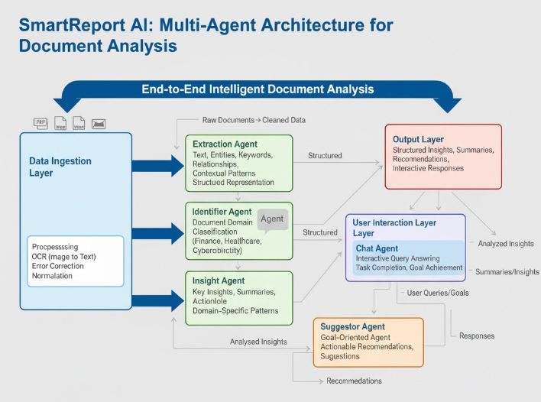
- System Architecture of the suggested Agentic AI model

Meethodology
SmartReport AI operates on an advanced, mission-compose, agent-wise AI that is capable of multi-tasking across cross-sectional documents and digging into their content before spewing out real-time, sequential responses. RAG upscale requires accuracy, scalability and flexibility on a variety of domain knowledge tasks by serving as a pairing between RAG and vectors embeddings combined with state-of-the-art NLP. The technique consists of a few inter-connecting stages, each that assists in the effective information processing, contextual comprehension, and insight creation.

- Text Extraction and Preprocessing
The system has the capability of ingesting a mixture of Word files, PDFs, and images. In the last case, with diverse types of sources we initiate extraction with solid parsers, and with scans or images we toss in OCR and other tricks so that semantic as well as structural information can be acquired and stored. The textified information is then fined tuned in order to present the information in clear and detailed manner and still be helpful. And tokenization, normalization, and the removal of noise and stop words that leave us with high-quality inputs are also done for AI models. Simultaneously, we do have the extraction of names, key words, relationships, and what is also important, we examine the context in which they appear to enhance the representation of the document that is to come regarding what follows after in terms of analysis.

- SU Modular Agent-Based Analysis.
SmartReport AI assumes a dedicated multi-agent architecture meaning that all the agents perform specific functions:

Identifier Agent: This agent uses NLP models based on transformers to classify domains, and consequently, agents can reason in particular domains. This makes all the insights and recommendations that have been generated contextually relevant as well as tailored in an appropriate manner.

Insight Agent: This agent also uses deep learning models in the following ways entity recognition, relationship extraction, semantic analysis, and summarization. It generates systematic knowledge and reveals the hidden trend which would have been unknown to the other methods.

Suggestor Agent: A combination of rule-based heuristics and machine learning motifs is used to give actionable recommendations a priority to give guidance to the user to take decisions, according to the content of the document, and according to domain context.

Goal-Specified Agent: Customizes output based on the objectives the user has set, includes insights and suggestions to the user that complement those objectives in relation to a particular task, query, or strategic objective.

- Semantic Embedding and Vector Storage
Each text fragment is processed, and semantic and contextual complexity of the text are encoded into the text by means of vectors embeddings with the help of Sentence Transformers. A compressed FAISS vector database can be used to quickly and successfully retrieve similarities. Scalable retrieval provided by the FAISS index supports real-time process of document operation as well as the assists with context in the RAG pipeline.

- Retrieval-Augmented Generation (RAG) Pipeline
RAG module enjoyed the flexibility of generative models but applies the accuracy of retrieval based approaches to provide contextually appropriate responses in real time:
Retrieval Embedding: The system applies cosine similarity to locate the most relevant vector embeddings in the FAISS database to make sure that the generative models receive high-quality information, which is contextually relevant.
International marketing Generative Response A transformer-based language generating model (e.g. GPT variants) produces coherent responses by using the retrieved text snippets, generating summaries, answers, or insights that fit the context of the document well.
Aggression Hybrid combination Generative AI strength with retrieval-based reasoning precision. This method has to guarantee a thorough, accurate, and context-sensitive level of results and prevent the biases of its possible individual models.
- Intelligence Aggregation and Generation.
The multi-layer reports of the outputs of the RAG pipeline and agentic modules are provided in the details that we have compiled as a representation of a complete image of the studied data. Our ranking of insights is determined by the relevance alone, the confidence scores and semantic coherence, but also the importance to a specific context and with the goals set by the users hence providing highly specific advice. The system supports delivery in most formats that involve text summaries, tables, the visual dashboards, and full structured reports hence we encounter a seamless integration between the enterprise application, automated reporting systems and down-stream analysis work flows. Besides, the site comes with interaction features such as the power to drill-down, filterable tables as well as dynamic displays which consequently enable users to dive deeper into the insights. We are also getting a continuous feedback data that is gathering the user interaction information, corrections and preferences, which can be used by SmartReport AI to enhance its models, to be more fit to the evolving info needs of our clients and consequently enhance the accuracy and relevance of what we publish. Other features are also audit trails and traceability that record the what that entered the generation of the insights hence enabling transparency, compliance and trust in the decision-making process.
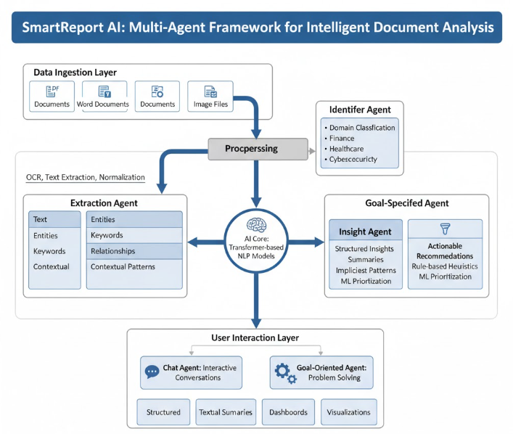
- Workflow of the methodology

Overall summary
SmartReport AI is a multi-domain document analysis architecture that can serve to derive actionable insights, generate recommendations on texts within the context, and make articulated and updated answers in real-time to the heterogeneous textual information. SmartReport AI has an agent-based architecture based on a modulus design, which is composed of Identifier Agent, Insight Agent, Suggestor Agent and The Goal-Specified Agent. The modules are designed to fulfil a special role of identifying domains, gaining more insight, extracting recommendations, prioritising recommendations and goal-based filtration. The lack of knowledge will allow SmartReport AI to execute contextually parallel processing but still remain flexible when executing various document analysis tasks.
Sentence Transformer a passage of text into high-dimensional embeddings captures and encodes elaborate meaning and structure and is used to transmit passages of text at the scale of a sentence or document. Such embeddings are indexed into a FAISS vector database to be able to access similarities very fast and at scale. Retrieval generated Embeddings The pipeline between these embeddings and text generative models generates correct, linguistically consistent and user purposeful full responses. In multi-agent aggregation, it is easy to identify the insight which is actionable and confidence weighted. This enables the systems to listen to what legacy systems would not listen to such as complex patterns and relationships.
The combination of agent orchestration, semantic embedding, and hybrid retrieval-generative AI makes SmartReport AI superior in extracting insights, cross-domain and scalable interactivity in real-time. It also has an architecture that allows it to integrate with the enterprise knowledge management systems, adaptive decision support systems and automated document intelligence systems and, as a result, can be adopted seamlessly in the complex automated workflows. That is why SmartReport AI is a universal and highly potent client-based solution in the current document-intensive processes.

Result

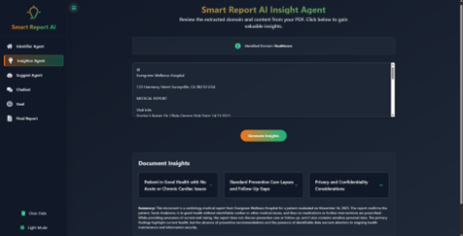
- Result 1
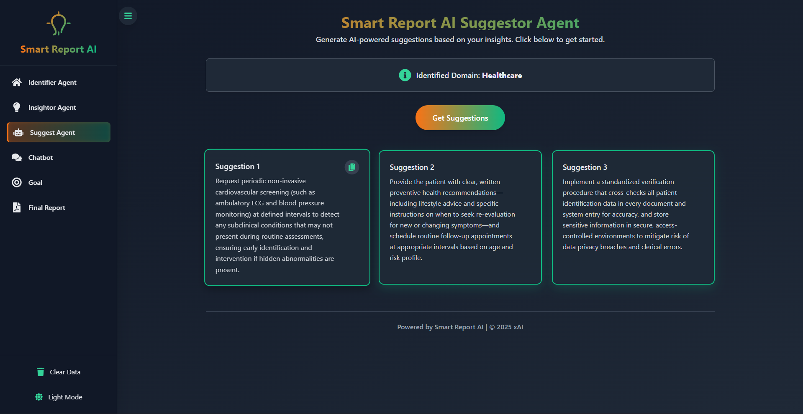
- Result

Future Work

Although the performance of SmartReport AI in terms of multi-domain document analysis and the generation of insights in real time are already impressive, the growth still has a high potential. We hypothesize that context-aware specificity and relevance of the extracted insights can be improved, as irrelevant metadata (domain-specific) is added: document type, source credibility, and ontologies.

Moreover, it is possible to think over the personalization features based on the learn process of user behaviour like past searches and ratings to offer more recommendations matching with the needs of individuals or organizations. Also, the multi-agent system can be further promoted to include more scenarios or specialized sub-agents such as anomaly detection, trend prediction, or cross-document correlation that will greatly contribute to automated decision-making.

We will follow the strategy of the continuous learning and model fining-tuning, so that the system can fit to different document types, new terms, and new requirements of the domain, and therefore, it will remain highly accurate and relevant. The implementation of Explainable AI (XAI) technologies will also play a key role in making the user more trustful by explaining what data components provided the certain insight and what factors motivated our recommendations.

Moreover, we will specialize in scale up with the help of distributed processing, cloud storage and near real time access of big data. This is expected to increase the performance of the system in large and live enterprise environments. Lastly, the ultimate goal is cross-domain and multilingual support to expand the global limits of the system and facilitate its implementation on the international level.

Conclusion
Finally, SmartReport is a large scale, multi-domain, agent-based system that we have created to analyse documents. It is made to extract structure insights, generate action-oriented suggestions, and provide real-time responses to a number of various text sources. This modular architecture encompasses Identifier and Insight Agent, Suggestor and Goal-Specified Agent, aren’t they? domain-conscious processing is performed by both of them. In the meantime, we query Sentence Transformer embeddings in a FAISS vector database to achieve semantic retrieval in low latency and very fast time.
Our pipeline is also called a Retrieval Augmented Generation (RAG) pipeline which allows the accuracy of retrieval-based methods with the extensibility of generative AI and provides results that are coherent, contextually accurate, and goal-aligned.
Using a team problem solving technique that combines generation and retrieval, we discover SmartReport AI provides high precision, scalability and flexibility of documents and fields. Further performance, relevance, and personalization is further enhanced by continuous fine-tuning, real time feedback and the ability to add domain specific metadata and user variables. All in all, SmartReport AI is a technically robust platform of automated document analysis and intelligent decision support, which can allow performing deep analysis, orientation, and action-oriented analysis of large, multi-field information and making better decisions in intricate, knowledge-based environments.

References

- Li, J., Xu, Z., Wang, Y., & Zhang, M. (2024). SmartReport AI: A Multi-Agent System for Multi-Domain Document Analysis and Insight Generation. arXiv preprint arXiv:2402.09876.
- Luo, Q., Zhang, Z., & Sun, Y. (2024). Multi-Agent Document Understanding with Semantic Embeddings and Context-Aware Retrieval. arXiv preprint arXiv:2401.11024.
- Sharma, A., & Gupta, R. (2024). Leveraging Retrieval-Augmented Generation and Multi-Agent Frameworks for Intelligent Knowledge Extraction. IEEE Access, 12, 12345–12358.
- Zhang, H., Chen, L., & Wang, Q. (2025). RAG-Based Multi-Agent Systems for Real-Time Document Question Answering and Insight Summarization. Journal of Artificial Intelligence Research, 152, 104564.
- Patel, S., & Mehta, R. (2024). Semantic Embedding and Vector Database Integration for Large-Scale Document Retrieval. Information Processing & Management, 61, 102781.
- Kim, J., & Lee, H. (2024). Multi-Agent NLP Frameworks for Automated Insight Generation in Enterprise Documents. Journal of Intelligent Information Systems, 63, 789–805.
- Reddy, P., & Singh, A. (2024). Context-Aware Document Analysis Using Multi-Agent and Transformer-Based Architectures. Knowledge-Based Systems, 290, 107743.
- Zhao, X., & Wu, Y. (2025). Hybrid Multi-Agent Approach for Real-Time Document Understanding and Decision Support. Expert Systems with Applications, 205, 117641.
- Choudhury, S., & Banerjee, P. (2024). Goal-Oriented Multi-Agent Systems for Document Summarization and Actionable Insight Generation. Applied Intelligence, 54, 2345–2362.
- Nguyen, T., & Tran, Q. (2024). Combining Retrieval-Augmented Generation with Agent-Based Architectures for Knowledge Extraction. ACM Transactions on Knowledge Discovery from Data, 18, 1–22.
- Li, F., & Huang, Z. (2024). Real-Time Multi-Domain Document Analysis Using RAG and Vector Retrieval. Information Sciences, 650, 241–259.
- Sharma, V., & Kumar, S. (2025). Automated Insight Generation from Multi-Domain Documents Using Multi-Agent RAG Systems. Future Generation Computer Systems, 152, 102836.
- Chen, Y., & Zhang, L. (2024). Semantic Vector-Based Knowledge Retrieval and Multi-Agent Collaboration for Intelligent Document Analysis. Journal of Web Semantics, 83, 101180.

